- About
Federal law requires that the University notify all faculty, staff, and students of certain information pertaining to unlawful possession, use, or distribution of illicit drugs and alcohol on its property or as part of its activity. The following information complies with the notification
requirements of the Drug-Free Schools and Communities Act (DFSCA) and its implementing regulations by providing standards of conduct, disciplinary sanctions, possible legal sanctions, and penalties.

- Drug-Free Schools and Communities Act Policy Statement
It is the policy of the University of Tennessee to maintain a safe and healthful
environment for its students and employees. Therefore, university policy
prohibits the unlawful use, manufacture, possession, distribution, or dispensing
of drugs ("controlled substances" as defined in the Controlled Substances Act,
21 U.S.C. 812) and alcohol on university property or during university activities.

Violation of this policy is grounds for disciplinary action -- up to and including immediate discharge for an employee and permanent dismissal of a student. Federal and state laws provide additional penalties for such unlawful activities, including fines and imprisonment (21 U.S.C. 841 et seq.; T.C.A. 39-6-401 et seq.). Local ordinances also provide various penalties for drug- and alcohol-related offenses. The university is bound to take all appropriate actions against violators, which may include referral for legal prosecution or requiring the individual to participate satisfactorily in an approved drug use or alcohol abuse assistance or rehabilitation
program.
Individuals who are paid by the University of Tennessee from federal grants or contracts must notify the University of any Criminal Drug Statute Conviction for a violation occurring in the workplace within five days after such conviction. The university is, in turn, required to inform the granting or contracting agency of such violation within ten days of the university's receipt of notification.
To maintain a safe and drug-free environment, University of Tennessee campuses and institutes may establish procedures to perform screenings for controlled substances and alcohol within areas or positions of employment that affect the public welfare or safety, or where such screenings are required by federal regulations, such as those developed by the Federal Highway Administration and Federal Aviation Administration. In addition, screenings are permissible where there is reasonable suspicion of drug or alcohol use.

Each University of Tennessee campus or institute conducting such screenings shall develop and document the necessary screening procedures. The procedures shall identify specifically the positions and locations that will require testing, the conditions under which the screenings will be conducted, and the specific plans for conducting the tests. Before implementation, all plans and procedures for such screenings must be approved by the Senior Vice President and Chief Financial Officer and the General Counsel. Costs of all required screenings will be borne by the individual campus or institute of the University of Tennessee.
A complete set of the drug screening procedures for employees in positions requiring the use of a commercial driver's license (CDL) is available for those employees and their supervisors from their campus or institute human resources office. The procedures discuss the types of screenings, when and how they are to be conducted, and the actions that will be taken by the university should the employee receive a confirmed positive alcohol or drug
test.

- Drug-Free Workplace Policy Statement

UT Policy-HR0720- Drug Free Campus and Workplace
It is the policy of the University of Tennessee to maintain a safe and healthful
environment for its students and employees. Therefore, university policy
prohibits the unlawful use, manufacture, possession, distribution, or dispensing
of drugs ("controlled substances" as defined in the Controlled Substances Act,
21 U.S.C. 812) and alcohol on university property or during university activities.

Violation of this policy is grounds for disciplinary action -- up to and including immediate discharge for an employee and permanent dismissal of a student. Federal and state laws provide additional penalties for such unlawful activities, including fines and imprisonment (21 U.S.C. 841 et seq.; T.C.A. 39-6-401 et seq.). Local ordinances also provide various penalties for drug- and alcohol-related offenses. The university is bound to take all appropriate actions against violators, which may include referral for legal prosecution or requiring the individual to participate satisfactorily in an approved drug use or alcohol abuse assistance or rehabilitation
program.
Individuals who are paid by the University of Tennessee from federal grants or contracts must notify the University of any Criminal Drug Statute Conviction for a violation occurring in the workplace within five days after such conviction. The university is, in turn, required to inform the granting or contracting agency of such violation within ten days of the university's receipt of notification.
To maintain a safe and drug-free environment, University of Tennessee campuses and institutes may establish procedures to perform screenings for controlled substances and alcohol within areas or positions of employment that affect the public welfare or safety, or where such screenings are required by federal regulations, such as those developed by the Federal Highway Administration and Federal Aviation Administration. In addition, screenings are permissible where there is reasonable suspicion of drug or alcohol use.

Each University of Tennessee campus or institute conducting such screenings shall develop and document the necessary screening procedures. The procedures shall identify specifically the positions and locations that will require testing, the conditions under which the screenings will be conducted, and the specific plans for conducting the tests. Before implementation, all plans and procedures for such screenings must be approved by the Senior Vice President and Chief Financial Officer and the General Counsel. Costs of all required screenings will be borne by the individual campus or institute of the University of Tennessee.
A complete set of the drug screening procedures for employees in positions requiring the use of a commercial driver's license (CDL) is available for those employees and their supervisors from their campus or institute human resources office. The procedures discuss the types of screenings, when and how they are to be conducted, and the actions that will be taken by the university should the employee receive a confirmed positive alcohol or drug
test.

- Standards of Conduct: Students
Students at the University of Tennessee are members of both the University community and the larger community of which the University is a part. Accordingly, students are responsible for conducting themselves in a lawful manner as well as in compliance with university rules and policies. In addition, the University has developed a set of aspirational goals titled, Principles of Civility and Community, which encourages all members of the University community to foster a learning environment where diversity is valued, respected, and celebrated.

Students are responsible for being fully acquainted with and for complying with the Code, the applicable undergraduate or graduate catalog, the student handbook (Hilltopics), and other rules and policies relating to students.

Alcohol Related Standards of Conduct
Consuming, manufacturing, possessing, distributing, dispensing, selling, or being under the influence of alcoholic beverages on university-controlled property or in connection with a University-affiliated activity unless expressly permitted by university rules or policy is a violation of Section 4.18 of the Student Code of Conduct.

Consuming, manufacturing, possessing, distributing, dispensing, selling, or being
under the influence of alcoholic beverages, if prohibited by federal, state, or local law is a violation of Section 4.19 of the Student Code of Conduct.

Providing an alcoholic beverage to a person younger than twenty-one (21) years of age, unless permitted by law is a violation of Section 4.20 of the Student Code of Conduct.

Drug and Drug Paraphernalia Standards of Conduct
Using, manufacturing, possessing, distributing, selling, dispensing, or being under the influence of drugs, if prohibited by federal, state, or local law; using, manufacturing, possessing, distributing, or selling drug paraphernalia, if prohibited by federal, state, or local law; using or possessing a prescription drug if the prescription was not issued to the student; or distributing or selling a prescription drug to a person to whom the prescription was not originally issued is a violation of Section 4.21 of the Student Code of Conduct.

- Standards of Conduct: Employees
UT Policy HR0580- Code of Conduct
The Code of Conduct was developed to supplement and clarify existing university policies, procedures, and rules. It does not replace, limit, or otherwise alter any existing policies. Employees are expected to familiarize themselves with the Code and to abide by it. Employees who violate the Code will be subject to appropriate disciplinary action. Employees should direct specific ethical or compliance questions to their supervisor or the university’s director of compliance.

Standards of Safety
Prohibits the unlawful manufacture, distribution, dispensation, possession, or use of alcohol, illegal drugs, intoxicants, or controlled substances; abuse of prescription drugs while on duty; use of alcohol in a university vehicle on or off university property; possession or use of alcohol while on duty (except at university-sponsored events and other events an employee is expected to attend as part of his or her duties); or reporting to work under the influence of illegal drugs or alcohol or while unlawfully using controlled substances.
- Student Sanctioning
Per Section 10.1.1 of the Student Code of Conduct, the purposes of sanctions include, without limitation: (1) to educate the Respondent about appropriate conduct; (2) to promote the personal and professional development of the Respondent; (3) to discourage the Respondent and other students from violating the Standards of Conduct; and (4) to protect other members of the University community. The sanctions imposed on a Respondent should be proportional to the Respondent’s misconduct and appropriate for the particular case based on the gravity of the offense (including, without limitation, how the violation affected or reasonably could have affected other members of the University community). Consideration may also be given to the Respondent’s conduct record; whether the Respondent acted in self-defense, and, if so, whether the amount of force used was reasonable under the circumstances; the Respondent’s academic classification (e.g., undergraduate, graduate, freshman, sophomore, junior, senior); and other aggravating or mitigating factors.

Administrative and Developmental Sanctions
A student who accepts responsibility or is found responsible for violating the Standards of Conduct generally will be given one (1) or more administrative sanctions. A student may also be given one (1) or more developmental sanctions.

Administrative Sanctions
Warning, Disciplinary Probation, Deferred Suspension, Suspension, Expulsion

Developmental Sanctions
Educational Activities, Restitution, Supervised Work/Service, Loss or Restriction of Privileges, University Housing Reassignment or Removal, Parental Notifications

- Employee-Specific Sanctioning
Violations of the Employee Code of Conduct are grounds for disciplinary action, up to and including termination of employment, pursuant to UT Policy HR0525.

Illegally using, manufacturing, possessing, distributing, purchasing or dispensing of controlled substances or alcohol as well as reporting for duty under the influence of intoxicants, constitutes gross misconduct under university policy. In a case of gross misconduct, immediate disciplinary action up to and including discharge may be taken. During the investigation of alleged gross misconduct, an employee may be placed on administrative leave with pay.

- Health Risks Associated with Alcohol and Other Drugs
Aside from any legal or university policy considerations, the use of illicit drugs and/or the misuse of alcohol may be harmful to one’s health. Some of the health risks associated with such use/misuse are:

Alcohol Misuse Health Risks
Over 30 percent of fatal auto accidents involve alcohol. Suicide is known to be highly prevalent among those who suffer from alcohol disorders.

Liver damage-cirrhosis, alcoholic hepatitis; heart disease-enlarged heart, congestive heart failure; ulcers and gastritis; malnutrition; cancer—of the mouth, esophagus, stomach, liver; brain damage-memory loss, hallucinations, psychosis; damage to fetus if pregnant mother drinks; death.

Common Drug Types and Risks
Cannabis
- Can increase anxiety and depression symptoms
- Increased risk of memory and learning problems
- Increased heart rate

Depressants
Alcohol, Benzodiazepines, Barbiturates, Sedatives
- Withdrawal can cause seizures or other harmful consequences
- Heartbeat and respirations decrease
- Risk of developing tolerance, dependance, or addiction is high

Stimulants
Cocaine, Nicotine, Methamphetamine
- Brain damage
- Anxiety, psychosis, hallucinations
- Addictive

- Drug and Alcohol Abuse Prevention Programs
Units in the university’s Division of Student Life (e.g., the Center for Health Education and Wellness, the Student Health Center, the Student Counseling Center, and the Office of the Dean of Students) are committed to promoting responsible decision-making regarding alcohol and drugs through educational programming,
resources, and referrals.

The university’s Employee Assistance Program may be reached directly at 855-437-3486, or www.Here4TN.com and manages the alcohol & drug abuse and rehabilitation program for benefits-eligible employees. The Employee Assistance Program also provides counseling and a variety of other referral services. For more information, visit http://hr.utk.edu/employee-relations/employee-assistance/.

- Center for Health Education and Wellness
The Center for Health Education and Wellness empowers all Volunteers to thrive by cultivating personal and community well-being. CHEW aims to fulfill this mission by helping the UT community prioritize holistic wellness.

CHEW’s prevention efforts are grounded in the Center for Disease Control’s Social Ecological Model. We utilize campus surveys, national statistics, and current research to inform our evidence-based prevention and intervention strategies.

Alcohol and Other Drug (AOD) Risk Reduction
Participants engaging with the AOD area/initiative will be able to:
- Make decisions that promote safe, healthy behaviors and reduce risk related to AOD use
- Appraise oneself accurately regarding their current AOD use
- Identify and utilize campus/community resources
- Demonstrate AOD misuse/use disorder awareness, understanding, and advocacy
eCHECKUP To Go
eCHECKUP To Go is a self-assessment tool available for use by students to examine their own alcohol use. The program provides immediate personalized feedback about:
- Drinking patterns
- Risk patterns
- Aspirations and goals
- Targeted risk reduction strategies
- Helpful on and off-campus resources

Alcohol Education Program (AEP)
The Alcohol Education Program (AEP) is a 2-hour online module for students to learn how to make more informed decisions about drinking. The goal is to consider what potential risks are for current behavior and how to modify behavior to reduce risk of negative consequences. Topics covered in this course include:
- Alcohol expectancy theory
- Assessment of use
- Alcohol and the body
- Blood alcohol concentration
- Biphasic effects of alcohol
- Polysubstance use
- Risk reduction strategies

Students are typically sanctioned to complete these sessions as a part of an alcohol violation. However, any student may request to complete this course voluntarily or meet with the Wellness Coordinator due to concerns or questions regarding their personal use of alcohol

BASICS
Brief Alcohol Screening and Intervention for College Students (BASICS) is a brief intervention program for students who have violated the alcohol policy at the University of Tennessee and meet criteria for being at higher risk. Our staff conducts BASICS in two one-on-one meetings with students. Motivational Interviewing techniques are the foundation for BASICS to meet students where they are to elicit change. The purpose of these meetings is to assess current pattern of use, engage students in a dialogue about their use, and provide resources. During these sessions, the student completes the online eCHECKUP TO GO – Alcohol assessment.
Students are typically sanctioned to complete these sessions as part of an alcohol violation. However, any student may volunteer to meet with the Wellness Coordinator due to concerns or questions regarding their personal use of alcohol.
Drug Education Program
The Drug Education Program (DEP) is a 2-hour online course for students to learn about the impact of substance use, reflect on personal use, and consider risk reduction strategies. The goal is to consider what potential risks are for current behavior and how to modify behavior to reduce risk of negative consequences. Topics covered in this course include:
- Assessment of use
- Cannabis
- Substances and the brain
- Tolerance and overdose
- Polysubstance use
- Risk reduction strategies

Students are typically sanctioned to complete these sessions as a part of a drug violation. However, any student may request to complete this course voluntarily or meet with the Wellness Coordinator due to concerns or questions regarding their personal use of substances.

Cannabis Screening & Intervention
Cannabis Screening & Intervention (CSI) is a brief intervention program for students who have violated the drug policy at the University of Tennessee and meet criteria for being at higher risk. Our staff conducts CSI in two one-on-one meetings with students. Motivational Interviewing techniques are the foundation for CSI to meet students where they are to elicit change. The purpose of these meetings is to assess current pattern of use, engage students in a dialogue about their use, and provide resources. During these sessions, the student completes the online eCHECKUP TO GO – Cannabis assessment.
Students are typically sanctioned to complete these sessions as a part of a drug violation. However, any student may volunteer to meet with the Wellness Coordinator due to concerns or questions regarding their personal use of cannabis.
Rocky Top Recovery
Rocky Top Recovery Group is a student organization at the University of Tennessee dedicated to supporting Volunteers in recovery from substance use disorder. Through fellowship, campus programming, and community service, we provide a healthy environment for students in recovery or interested in recovery. We promote personal development, academic success, and civic duty to the University of Tennessee community and beyond.

- Local, State and Federal Laws*

Alcohol
All members of the university community and guests are required to comply with university policies and federal, state and local laws regarding the distribution, possession and consumption of alcoholic beverages.

Knoxville Local Ordinances
Sec. 4-35.- Purchase or possession by underage person prohibited; misrepresentation of age.
- Any person under the age of twenty-one (21) years who purchases, receives or has beer in his possession shall be guilty of a misdemeanor.
- Any person under the age of twenty-one (21) years who knowingly misrepresents or makes a false statement to the effect that he is twenty-one (21) years old or older to any person engaged in the sale of beer, for the purpose of obtaining the beer, shall be guilty of a misdemeanor.
Tennessee State Law
§ 1-3-113- Underage purchasing, possession, transportation or consumption of alcoholic beverages, wine or beer is a Class A misdemeanor
§ 39-15-404- It is a Class A misdemeanor offense for a person to give or buy alcoholic beverages or beer for or on behalf of a minor or to cause alcohol to be given or bought for or on behalf of a minor for any purpose

Illegal Drugs
Various federal and Tennessee laws make it unlawful to manufacture, distribute, dispense, deliver, or sell or possess with intent to manufacture, distribute, dispense, deliver, or sell controlled substances.
Tennessee State Law
§ 39-17-418- Simple possession or casual exchange.
It is an offense for a person to knowingly possess or casually exchange a controlled substance, unless the substance was obtained directly from, or pursuant to, a valid prescription or order of a practitioner while acting in the course of professional practice.

Depending on the circumstances, this offense is either a Class A misdemeanor or a Felony.

In Tennessee, Class A misdemeanors carry up to 11 months, 29 days in jail, and or fines up to $2,500.00.

Federal Illegal Drug Laws
The Controlled Substance Act provides penalties for unlawful manufacturing, distribution, and dispensing of controlled substances. An overview of federal penalties and Scheduling is found below:
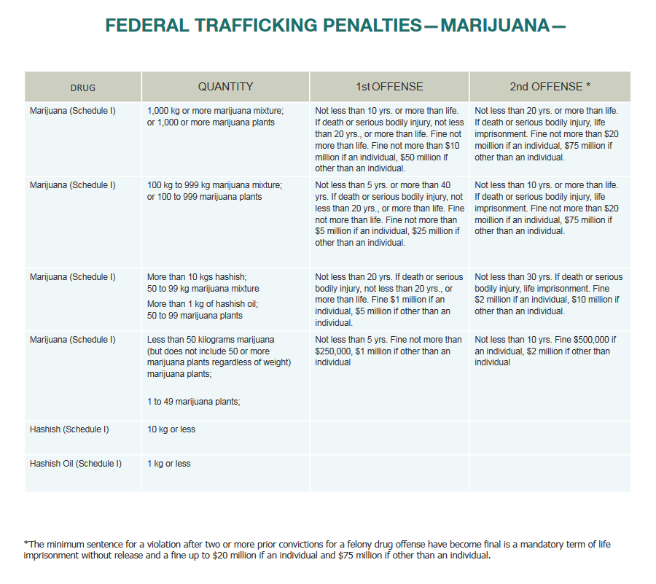
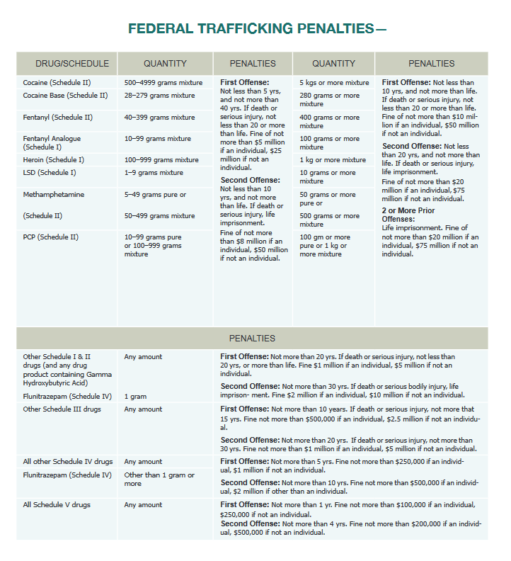
Document can be found here

*The information provided as a brief summary of laws and not an exhaustive list, as they are subject to change.

- Resources (On-Campus and Community)
Campus Resources
Center for Health Education and Wellness
Counseling Center
Student Conduct & Community Standards
Human Resources
Community Resources
Cornerstone of Recovery
CenterPointe
Peninsula Lighthouse and Outpatient Centers
Tennova Behavioral Health Services
Blount Memorial Behavioral Health
Metro Drug Coalition (MDC)

